|  |
| --- |
| ***Quarterly Statistical Release*** |

**March 2017, N° 68**

***This release and other statistical***

***releases are available on Efama’s***

***website (***[***www.efama.org***](http://www.efama.org)***)***

***Trends in the European Investment Fund Industry***

***in the Fourth Quarter of 2016***

***&***

***Results for the Full Year of 2016***

|  |
| --- |
| **This report was prepared by Bernard Delbecque and Alex Carroll**  **EFAMA**  **The European Fund and Asset Management Association**  **Rue Montoyer 47 - B-1000 BRUXELLES - Tel. 32-2-513.39.69 Fax: 32-2-513.26.43 - e-mail: info@efama.org** |

**Highlights**

**2016 was another record year for the European investment fund industry, with net assets of European investment funds rising to an all-time high of EUR 14,142 billion and net sales of AIF reaching an all-time high of EUR 184 billion. Although lower than in the record-breaking years of 2014 and 2015, the net sales of UCITS were higher in 2016 than any single year from 2007 to 2013.**

**Further highlights on the developments in 2016 include:**

* Net sales of UCITS reached EUR 275 billion, compared to EUR 590 billion in 2015 and EUR 189 billion on average in 2007-2013.

* Equity funds suffered a negative turnaround in net sales in 2016, as net sales never really recovered from the stock market sell-off in January.
* After three years of constantly increasing net sales, multi-asset funds suffered a sharp fall in net sales in 2016, as investors tried to limit their – direct and indirect – exposure to stock markets.
* After a difficult first quarter, bond funds enjoyed a strong rise in net inflows on the back of falling long-term interest rates.
* The higher uncertainty and renewed downside risks continued to increase the demand for money market funds in 2016, in spite of very low returns.
* Cross-border UCITS domiciled in Ireland and Luxembourg attracted 69% of total UCITS net sales.
* Net sales of AIF reached EUR 184 billion, compared to 148 billion in 2015.
* AIF surpassed net sales of long-term UCITS (EUR 183 billion, compared to EUR 169 billion).
* Multi-asset funds were the clear winners among the mainstream asset classes, followed by real estate funds, bond funds and equity funds.
* The move into “other” AIFs continued in 2016, as investors diversified more widely and focused more on investment outcomes.
* AIFs domiciled in Germany captured 53% of the total net sales of AIFs.



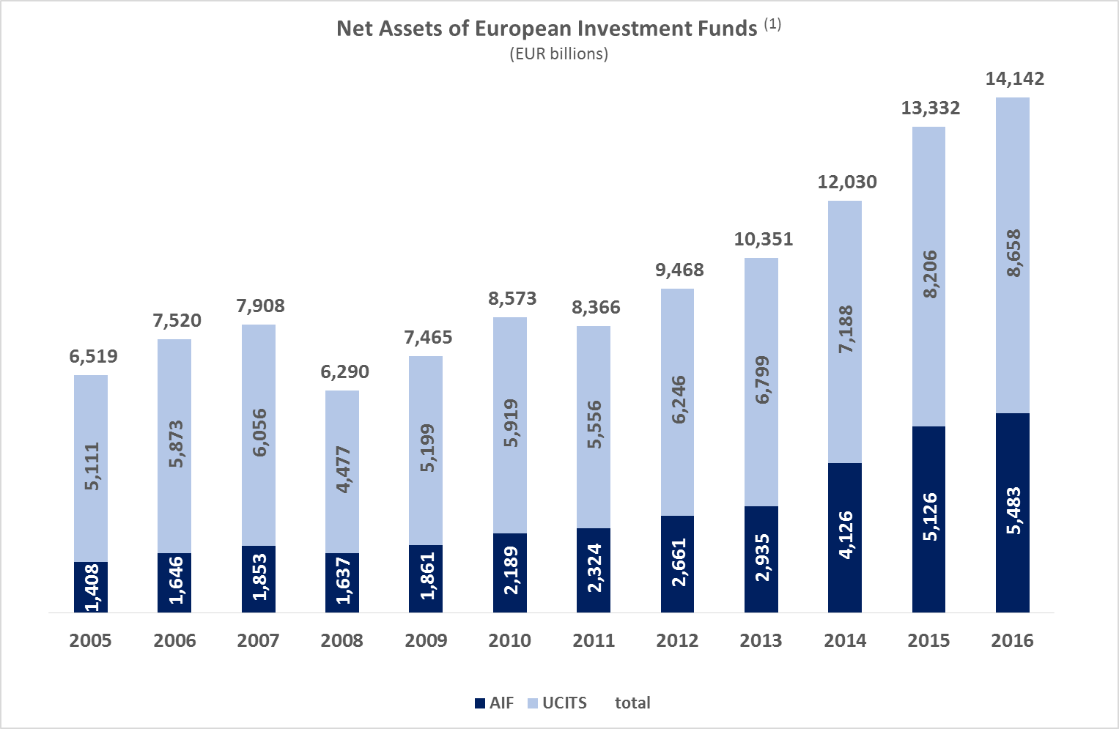

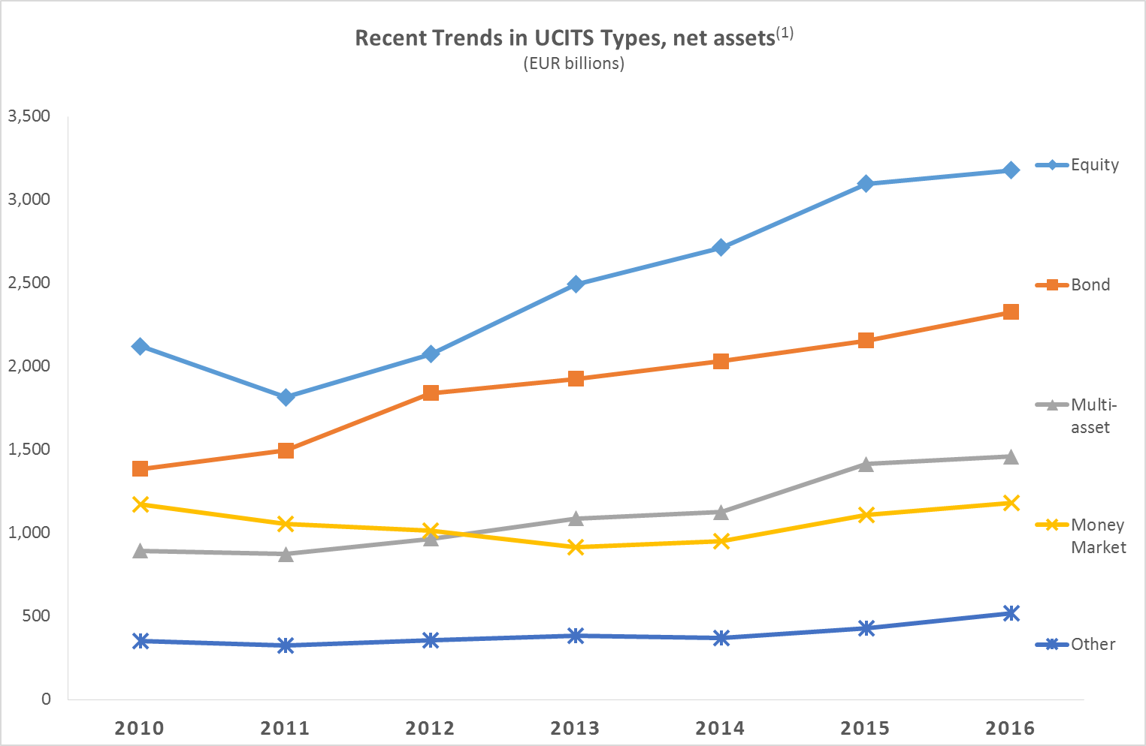

(1) Source: EFAMA database, annual data. Data for 2016 excludes data on Belgian net sales due to unavailability.

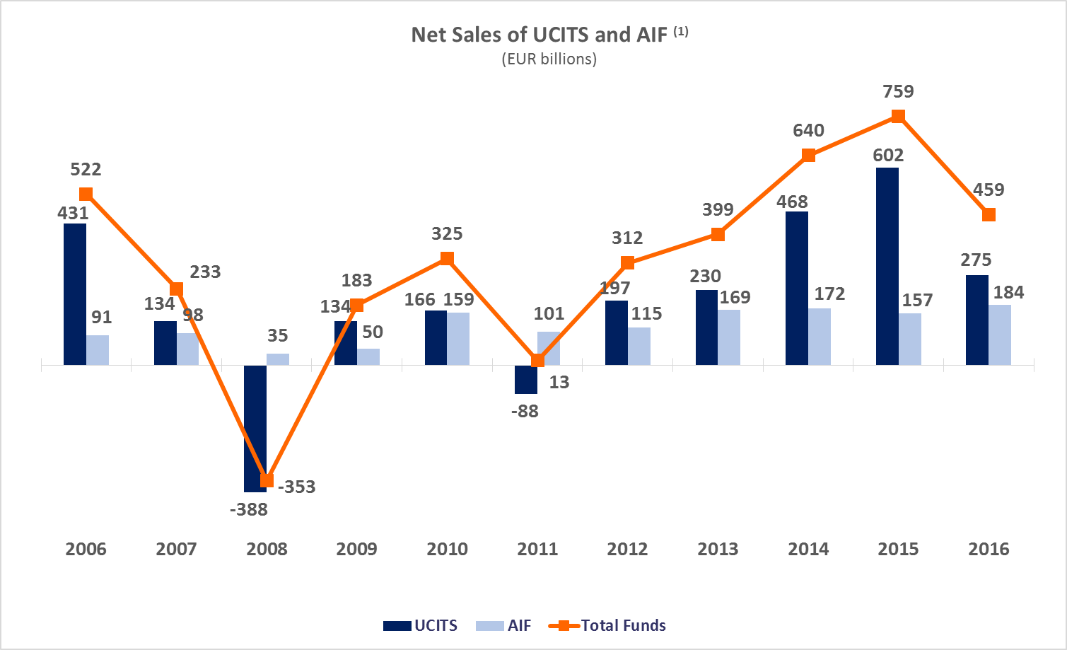

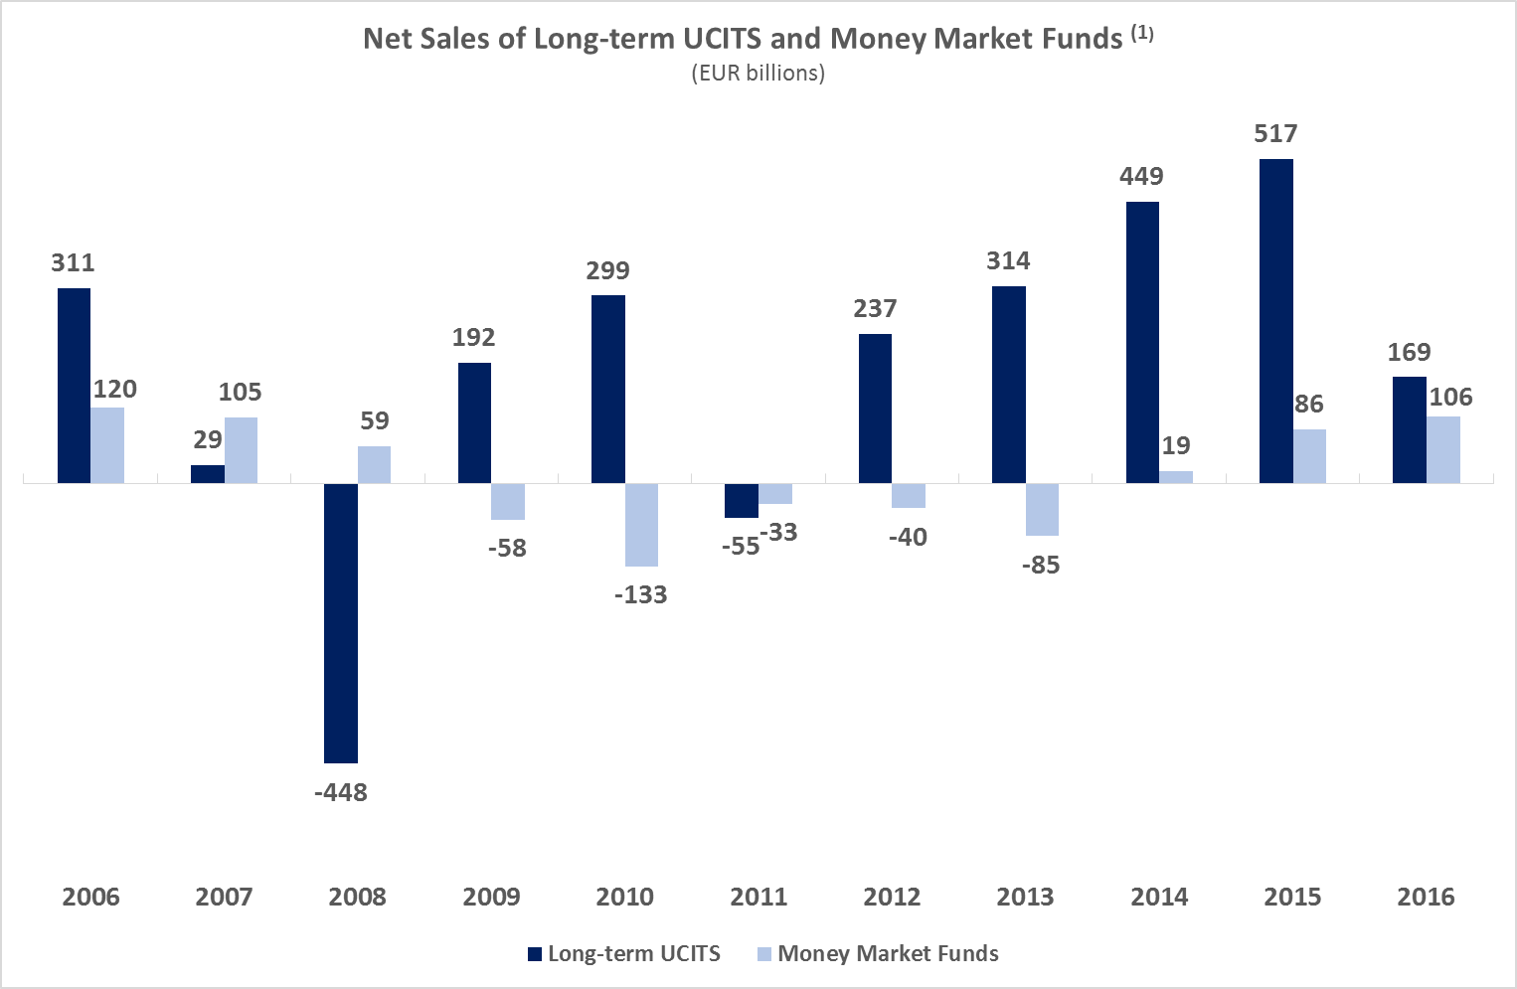

**Top Ten Domiciles in 2016**

(1) Source: EFAMA database, annual data. Data for 2016 excludes data on Belgian net sales due to unavailability.

***Largest Domiciles in terms of Net Assets and Net Sales***

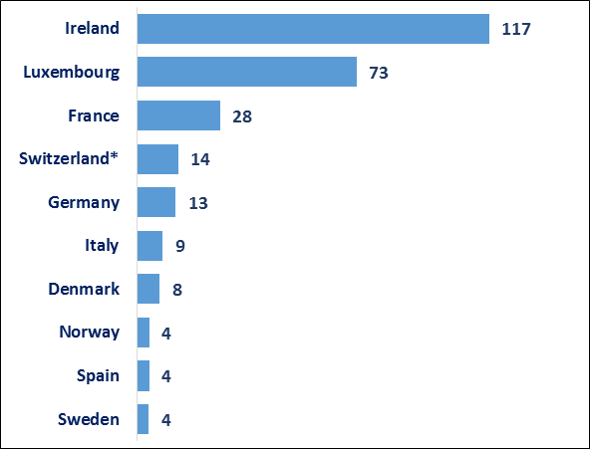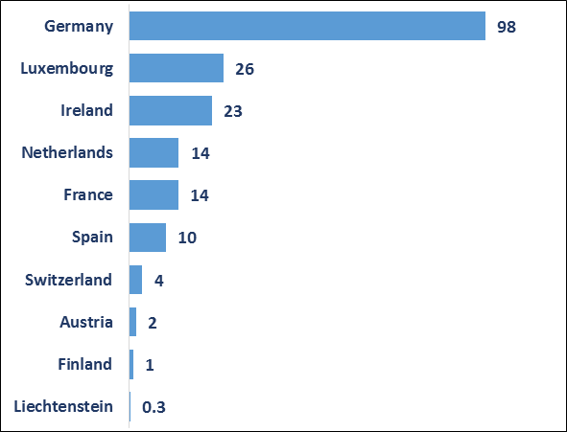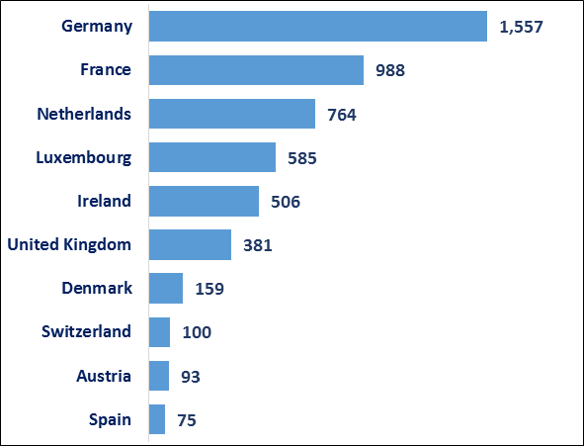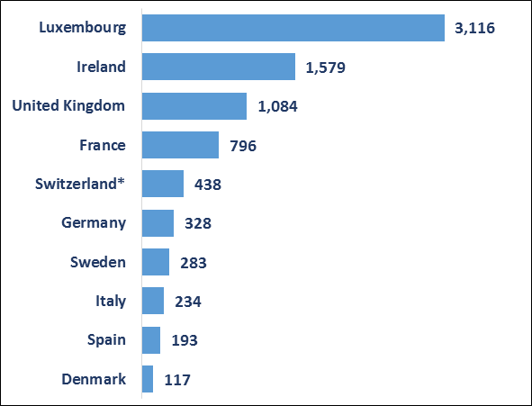

*Funds domiciled in Switzerland that fulfill the UCITS criteria are classified as UCITS in this report.

**UCITS FUNDS**

**Net Assets at end 2016**

**(EUR billion)**

**Net Sales in 2016**

**(EUR billion)**

**Net Assets at end 2016**

**(EUR billion)**

**Net Sales in 2016**

**(EUR billion)**

**AIF FUNDS**

**Trends in the UCITS Market**

***Net Sales by Investment Type***

**Net sales of UCITS totaled EUR 82 billion in Q4 2016, down from EUR 129 billion in Q3 2016. In 2016, UCITS garnered net sales of EUR 275 billion, compared to EUR 590 billion in 2015.**

Long-term UCITS attracted net inflows of EUR 45 billion, down from EUR 84 billion in the third quarter. Equity finished the year with inflows of EUR 13 billion, compared to EUR 1 billion in the previous quarter. Multi-asset funds registered net sales of EUR 15 billion, slightly up from the EUR 13 billion registered in the third quarter. Inflows of bond funds decreased from EUR 63 billion to EUR 16 billion in Q4 2016. Money market funds posted net inflows of EUR 36 billion, down from EUR 45 billion in the previous quarter.

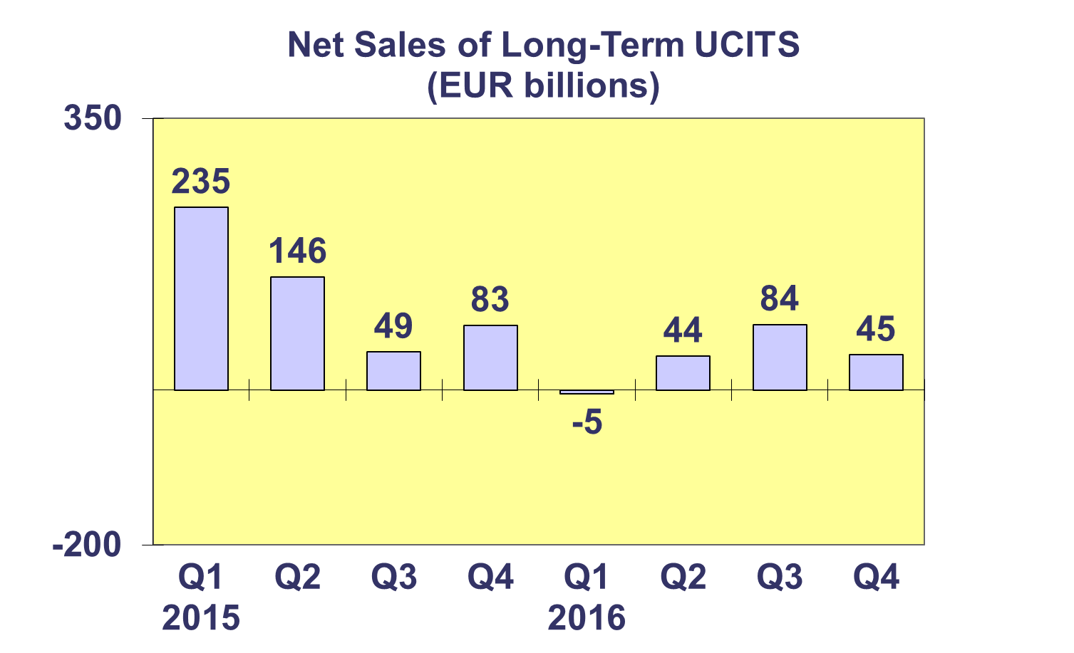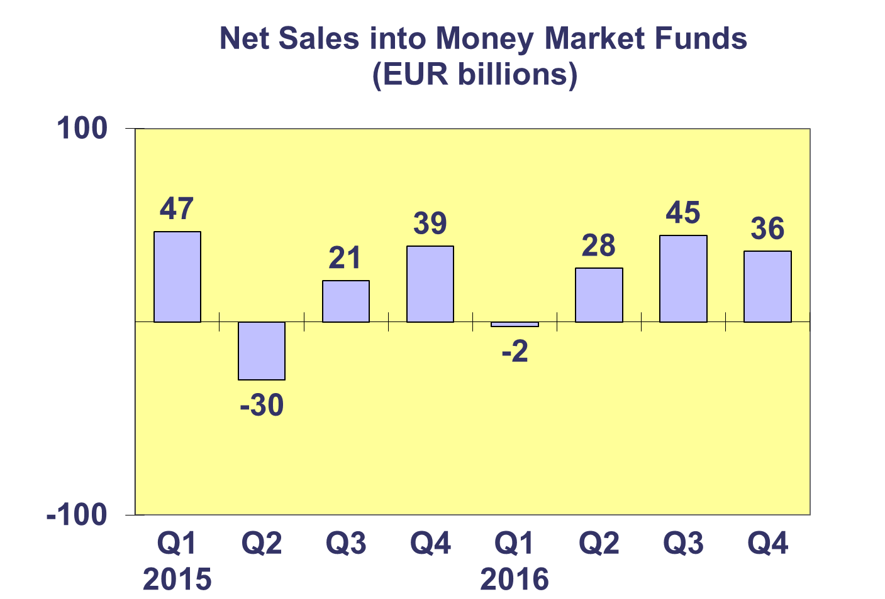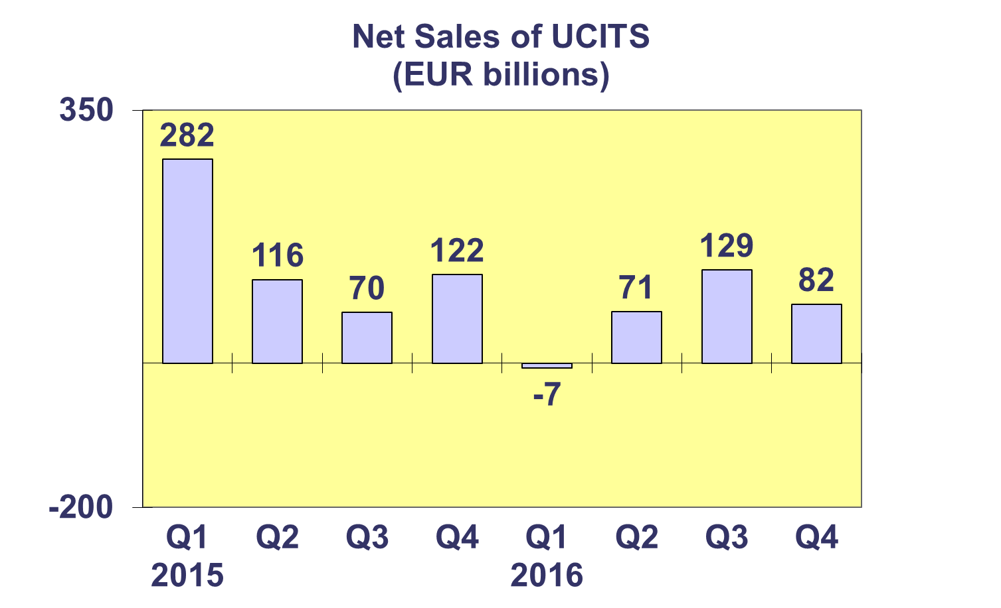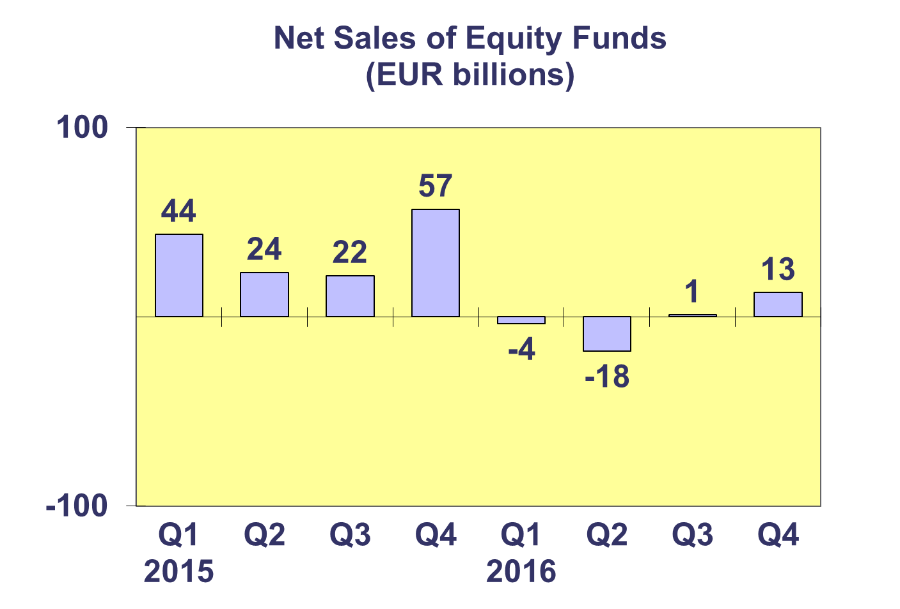

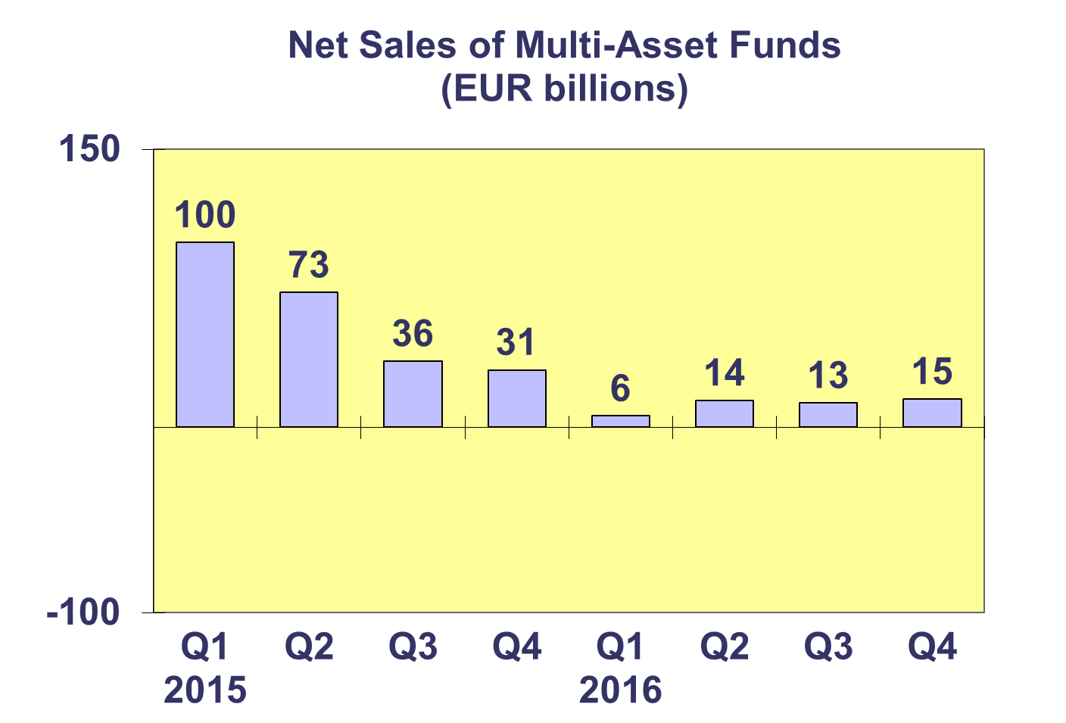

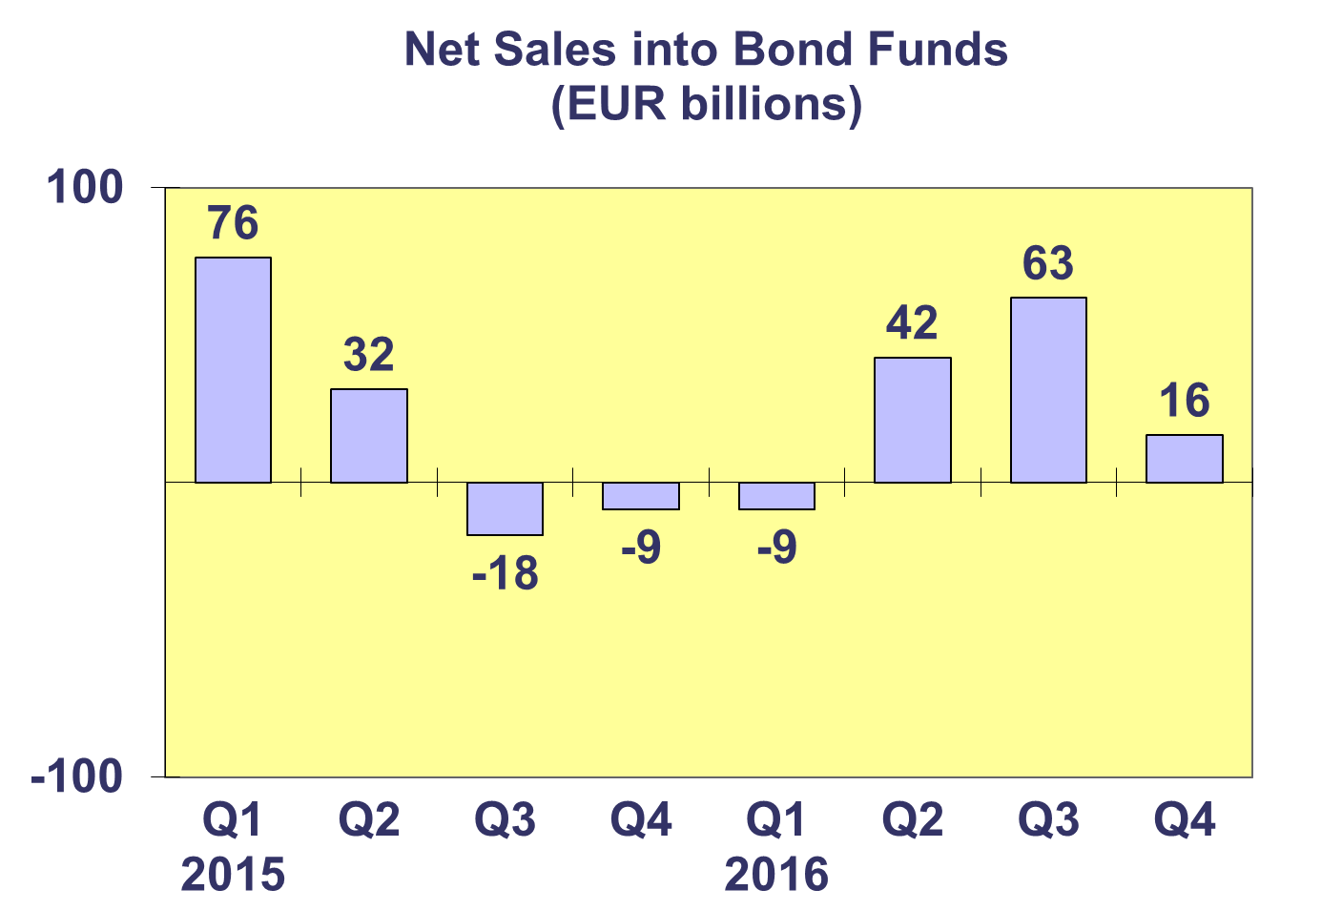

**Trends in the UCITS Market**

***Net Assets by Investment Type***

**In the first two quarters of 2016, the UCITS market was marked by volatility while the last two quarters saw increasing demand.** After months of net outflows and low demand, equity funds ended the year with two months of modest but positive net inflows.Net sales of bond funds saw strong demand in the middle of the year, with more volatility in the first and fourth quarters of the year. Multi-asset funds also experienced decreased demand in the first and final quarter of the year with relatively stable net sales in Q2 and Q3. Money market funds registered habitual end of quarter net outflows during the first two quarters of the year, whereas the last two quarters demonstrated strong demand.

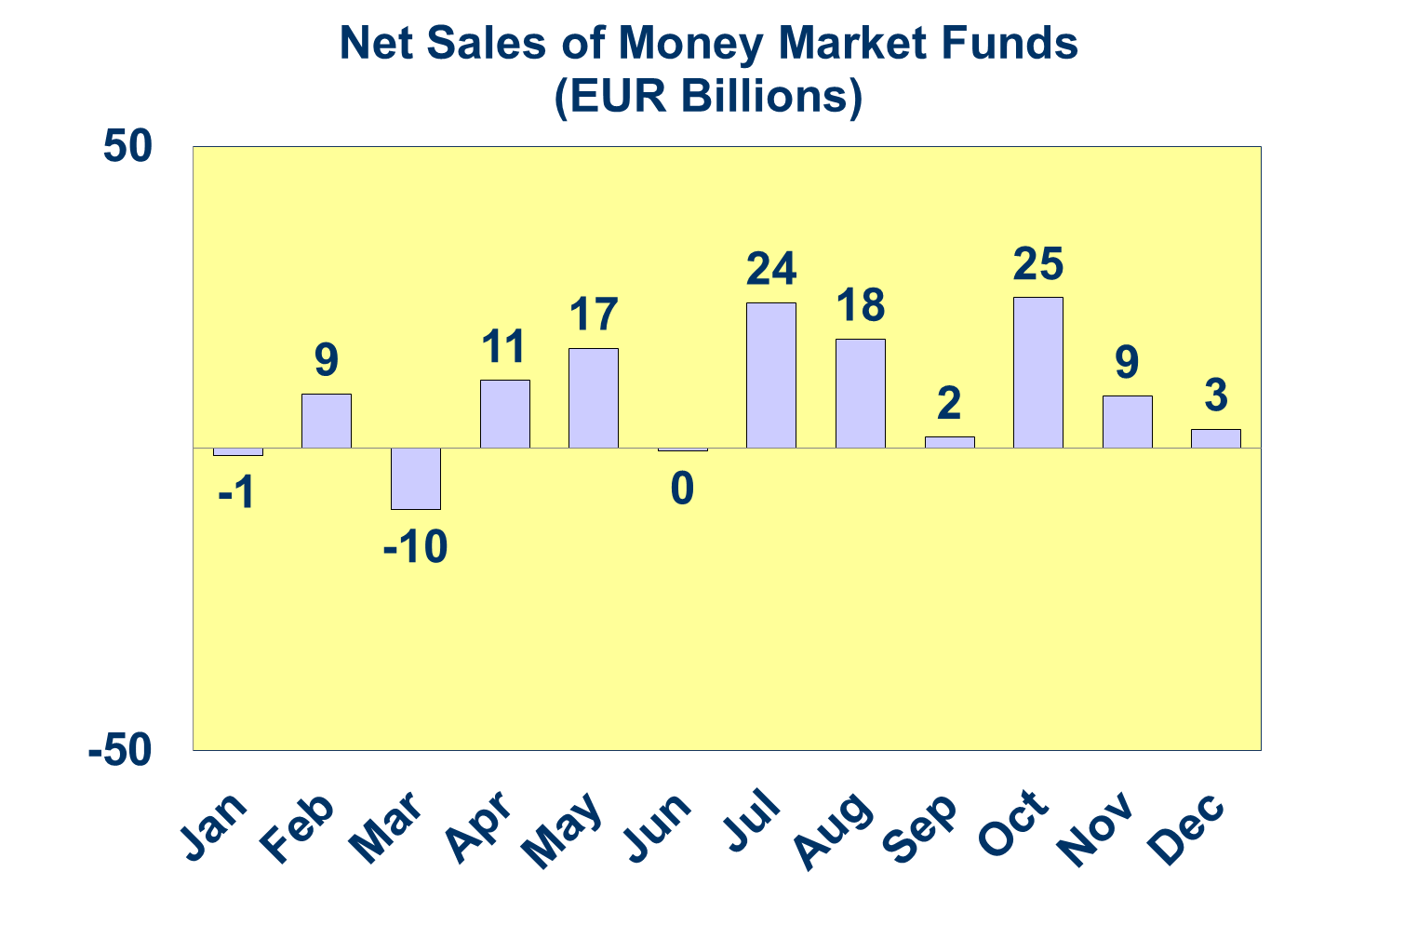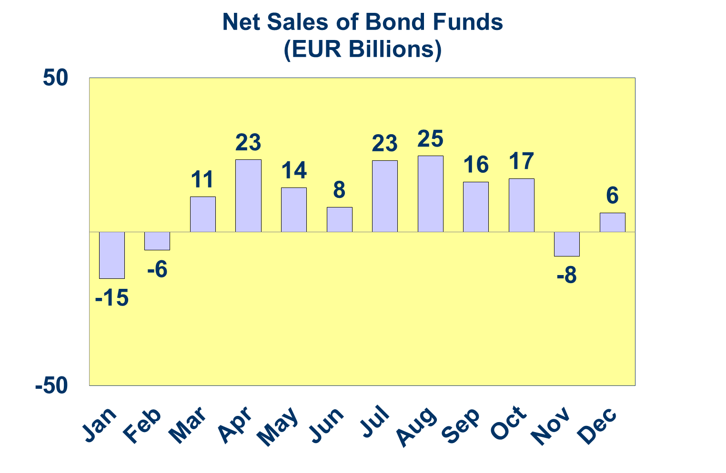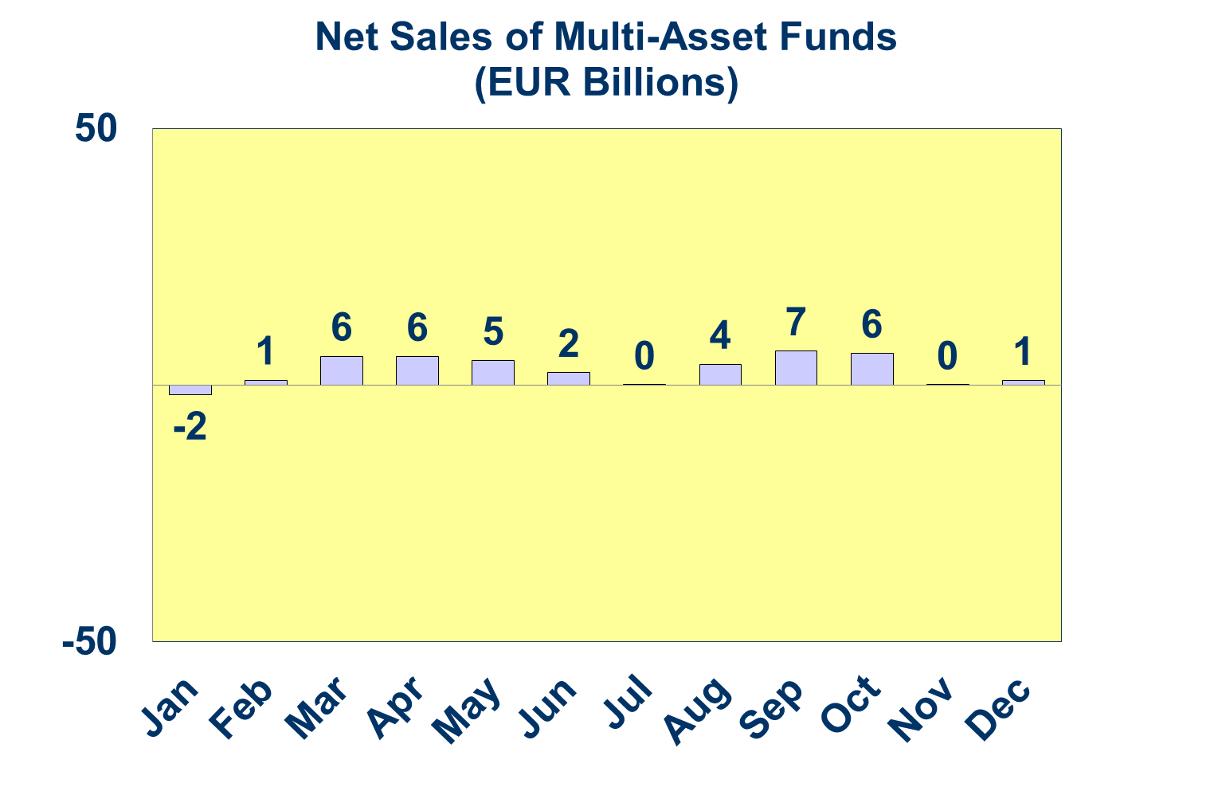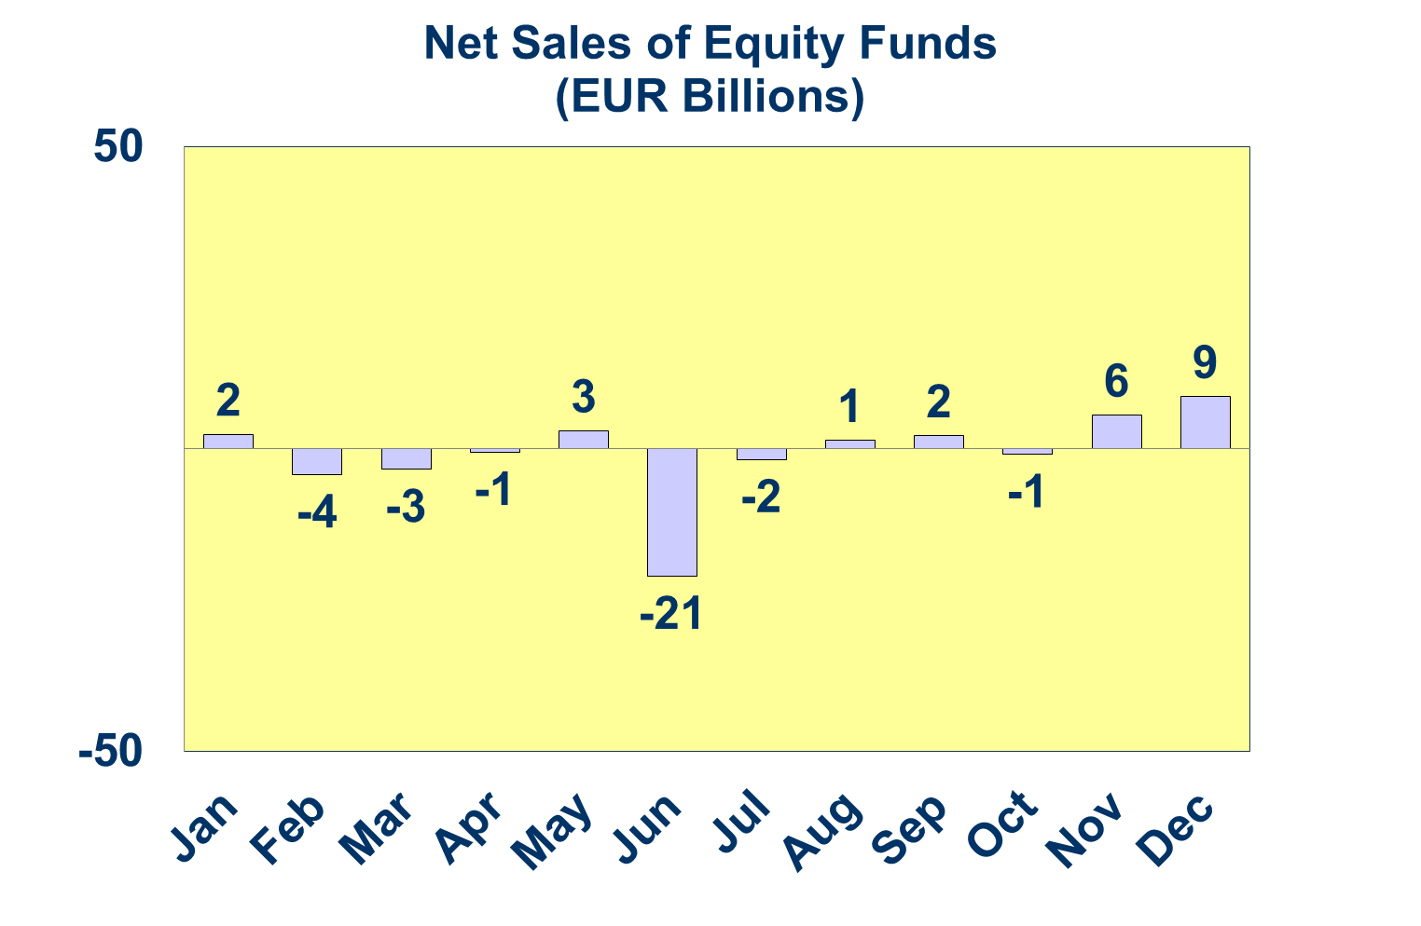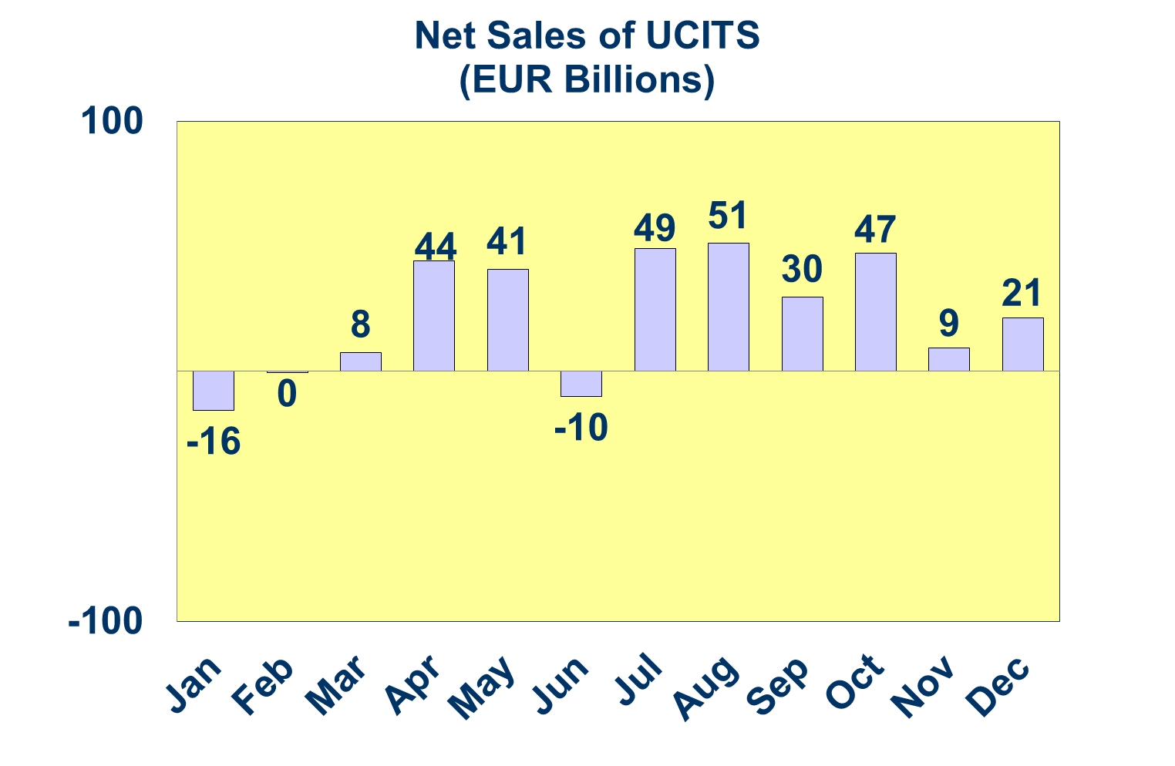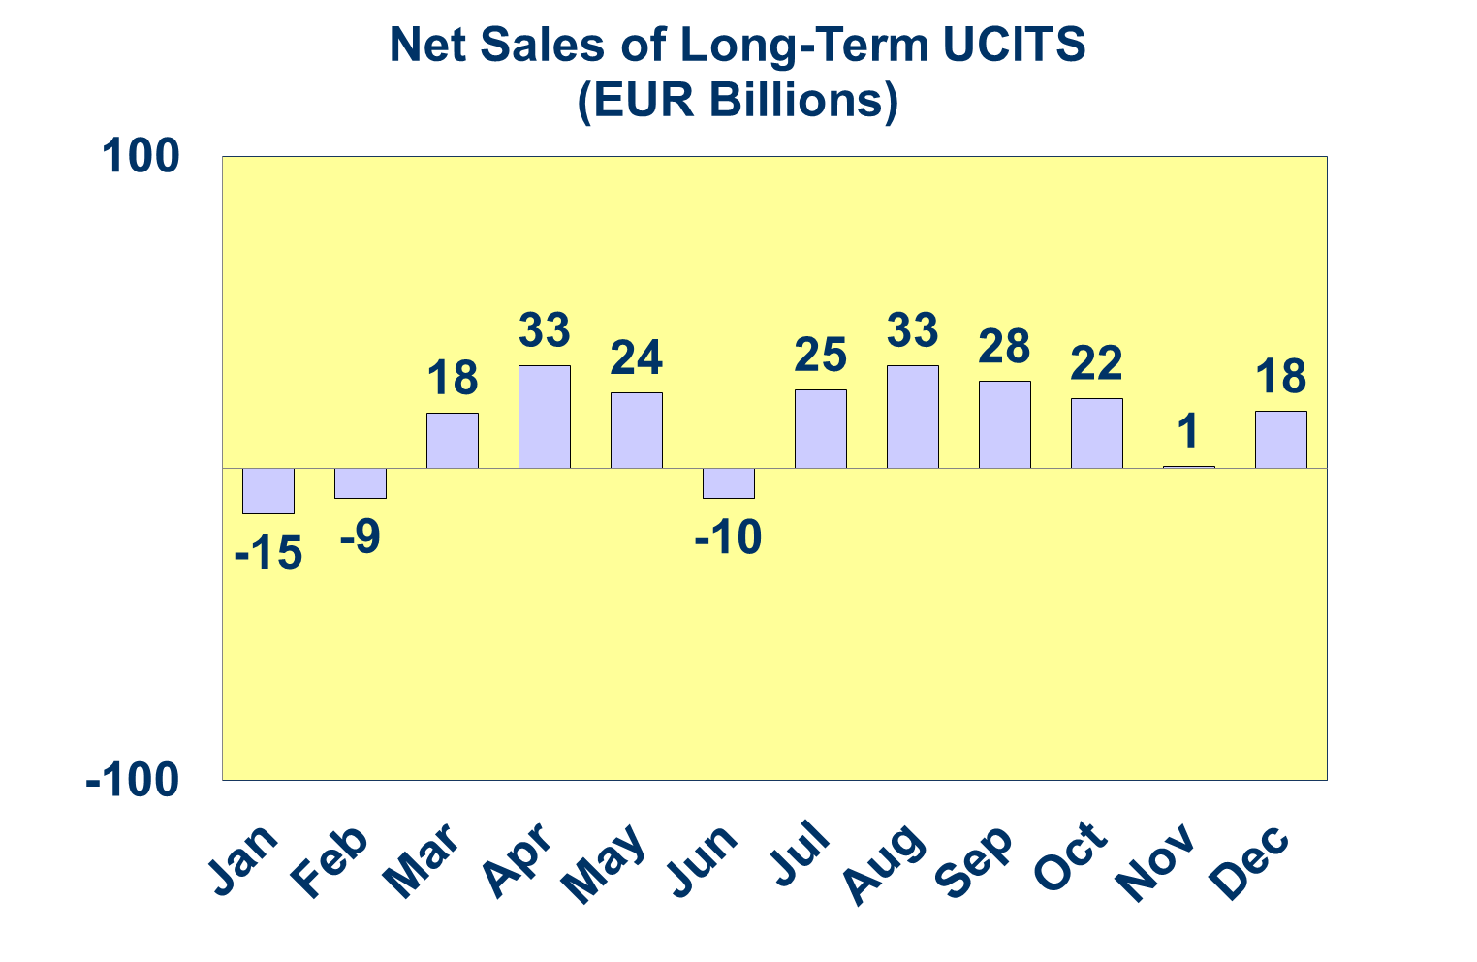

**Trends in the UCITS Market**

***Net Sales by Country of Domiciliation and Investment Type***

**Twenty countries registered net inflows into UCITS in the fourth quarter of 2016, with ten countries recording net inflows above EUR 1 billion.**

Among the largest domiciles, Ireland attracted net sales of EUR 47 billion in Q4 2016, driven by strong net inflows into equity, bond and money market funds. France experienced net inflows of EUR 8 billion, mainly thanks to bond and money market funds. The UK recorded net sales of EUR 6 billion, also due to strong inflows into bond, money market and other funds. Germany attracted 4.5 billion in net sales, mostly thanks to strong demand for equity funds. Strong net inflows into UCITS funds were also seen in Italy (EUR 4.1 billion), Sweden (EUR 3.7 billion), Spain (EUR 2.7 billion) and Denmark (EUR 2.6 billion).

Five countries ended the year with cumulative net sales greater than EUR 10 billion: Ireland (EUR 117 billion), Luxembourg (EUR 73 billion), France (EUR 28 billion), Switzerland (EUR 14 billion) and Germany (EUR 13 billion).

 **Trends in the UCITS Market**

***Net Sales and Net Assets of ETF by Country of Domiciliation***

**Net sales of UCITS ETFs reached EUR 14.7 billion in Q4 2016 and EUR 44.0 billion in 2016.[1]**

UCITS ETF domiciled in Ireland registered the largest inflows during the quarter (EUR 8.2 billion), reflecting the size of their ETF market, followed by France (EUR 3.8 billion) and Germany (EUR 2.7 billion). In 2016, Ireland attracted the largest net inflows (EUR 40.9 billion), followed by France (EUR 2.9 billion).

For the group of countries reporting net sales of ETF, the total net sales of ETF in 2016 represented 25% of their total net sales of UCITS. In Ireland, the share of ETF represented 35% of the total net sales of UCITS.

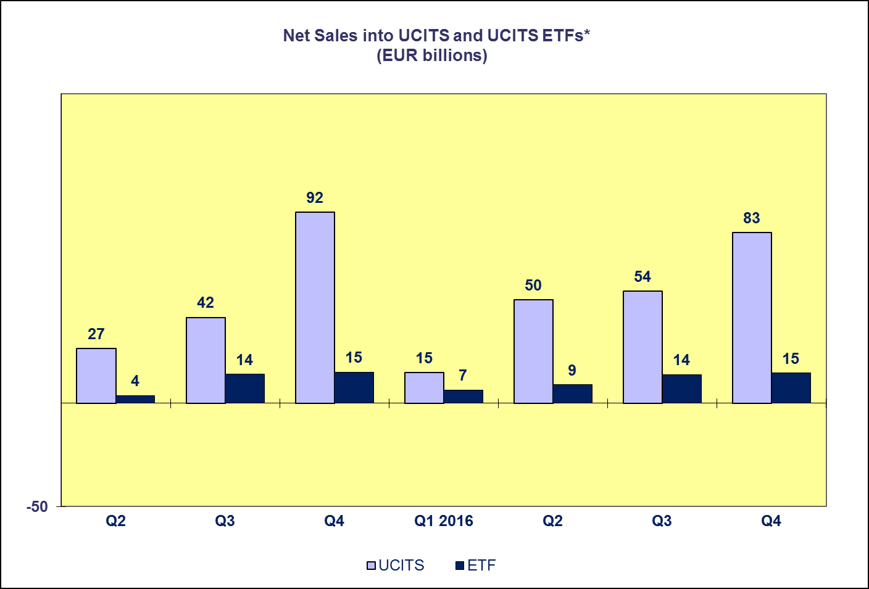**Trends in the UCITS Market**

* Both UCITS and UCITS ETF data exclude net sales of funds domiciled in Luxembourg.

***Net Assets by Investment Type***

**UCITS net assets increased by 3.2 percent in Q4 2016 to reach EUR 8,658 billion at end 2016.**

All categories of UCITS funds experienced an increase in net assets in 2016. Equity and money market funds both recorded increases of 5.2 percent. Net assets of multi-asset funds increased by 2.5 percent, followed by other funds (2.3%), bond funds (0.5%) and guaranteed funds (0.4%). In terms of annual growth, the mainstream categories with the largest growth were bond funds (7.9%) and money market funds (6.3%). The largest decrease in net assets in 2016 was seen in guaranteed funds (11.4%).

The number of UCITS funds increased from 30,057 at end Q4 2015 to 30,674 at end Q4 2016.



**Trends in the UCITS Market**

***Net Assets by Country of Domiciliation***

**The vast majority of domiciles recorded net asset growth in the fourth quarter as net assets of UCITS reached EUR 8,658 billion at end 2016.**

Among the major domiciles, the largest increases in net assets in Q4 2016 were seen in Ireland (6.1%), followed by Germany (4.1%), France (2.7%), Luxembourg (2.1%) and the UK (3.3%). All Nordic countries experienced net asset growth, with the largest growth in Sweden (7.0%), followed by Denmark (4.5%), Finland (4.1%) and Norway (2.2). In Southern Europe, the largest net asset growth was seen in Cyprus (21%), Greece (3.2%) and Spain (2.9%) with Malta experiencing a decrease in net assets of 3.5 percent. Strong increases in net assets were also seen in Central and Eastern Europe, with the largest increase in Hungary (16.3%), followed by Bulgaria (11.2%) and the Czech Republic (4.1%), with the largest the largest net asset decreases in Romania (2.2%).

Net assets of UCITS reached EUR 8,658 billion by end Q4 2016, representing an increase of 3.2% in Q4 2016 and 5.5% in 20016.

**Trends in the AIF Market**

***Net Sales by Investment Type***

**AIF recorded net inflows of EUR 39 billion during Q4 2016, down from EUR 43 billion in the previous quarter. In total, AIF garnered net sales of EUR 184 billion in 2016, compared to EUR 148 billion in 2015.**

Long-term AIF recorded net sales of EUR 37 billion, down from net sales of EUR 44 billion in Q3 2016. Both equity and bond funds recorded net outflows for the first time this year, with net outflows of EUR 6 billion and EUR 3 billion respectively. Net sales of multi-asset funds registered EUR 17 billion, up from EUR 11 billion in Q3. Net sales of real estate funds registered net sales of EUR 5 billion, up from EUR 2 billion in Q3.

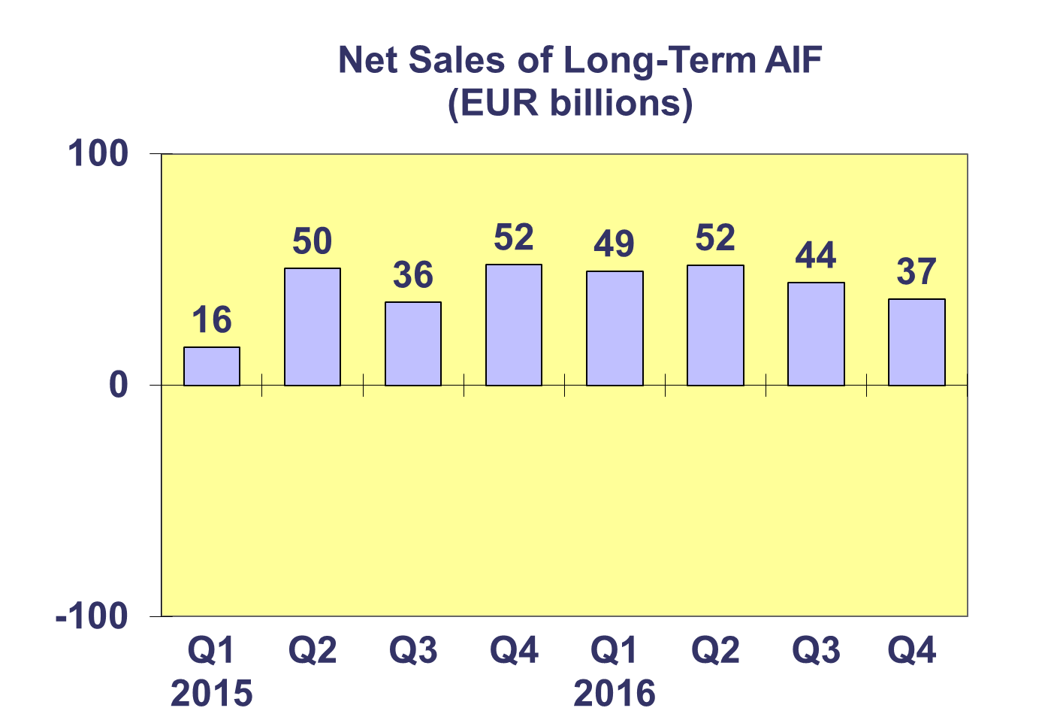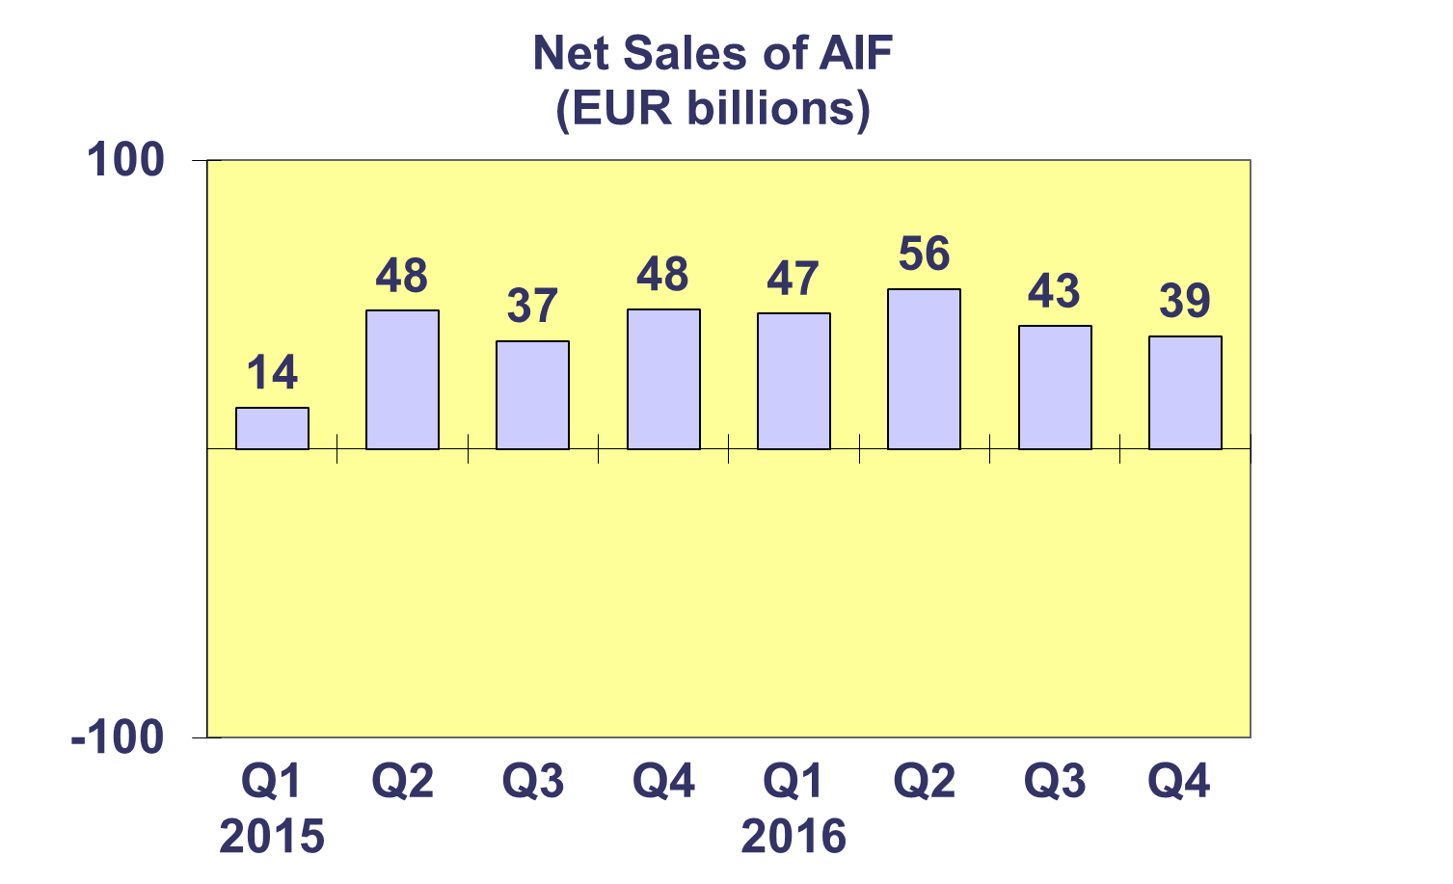

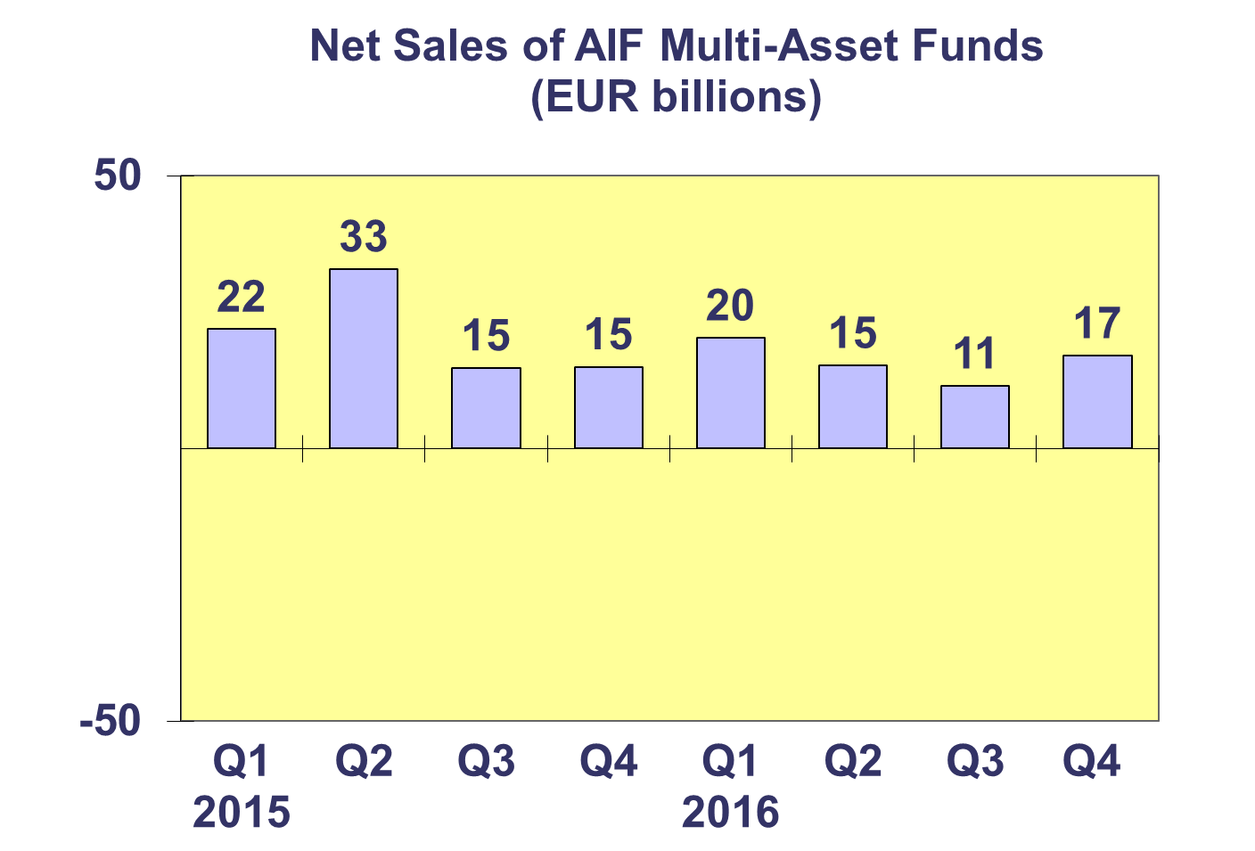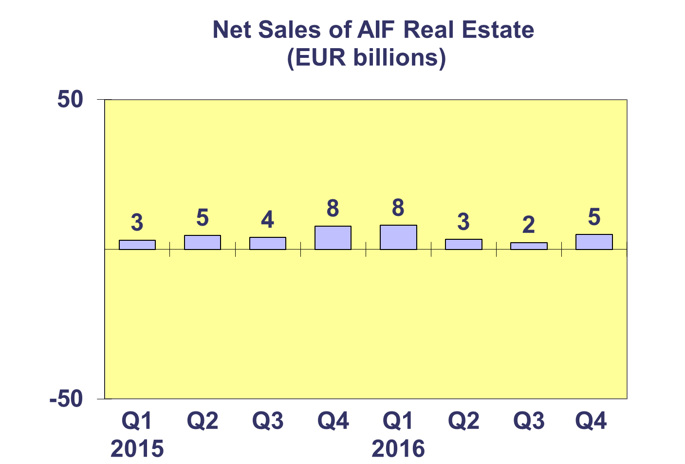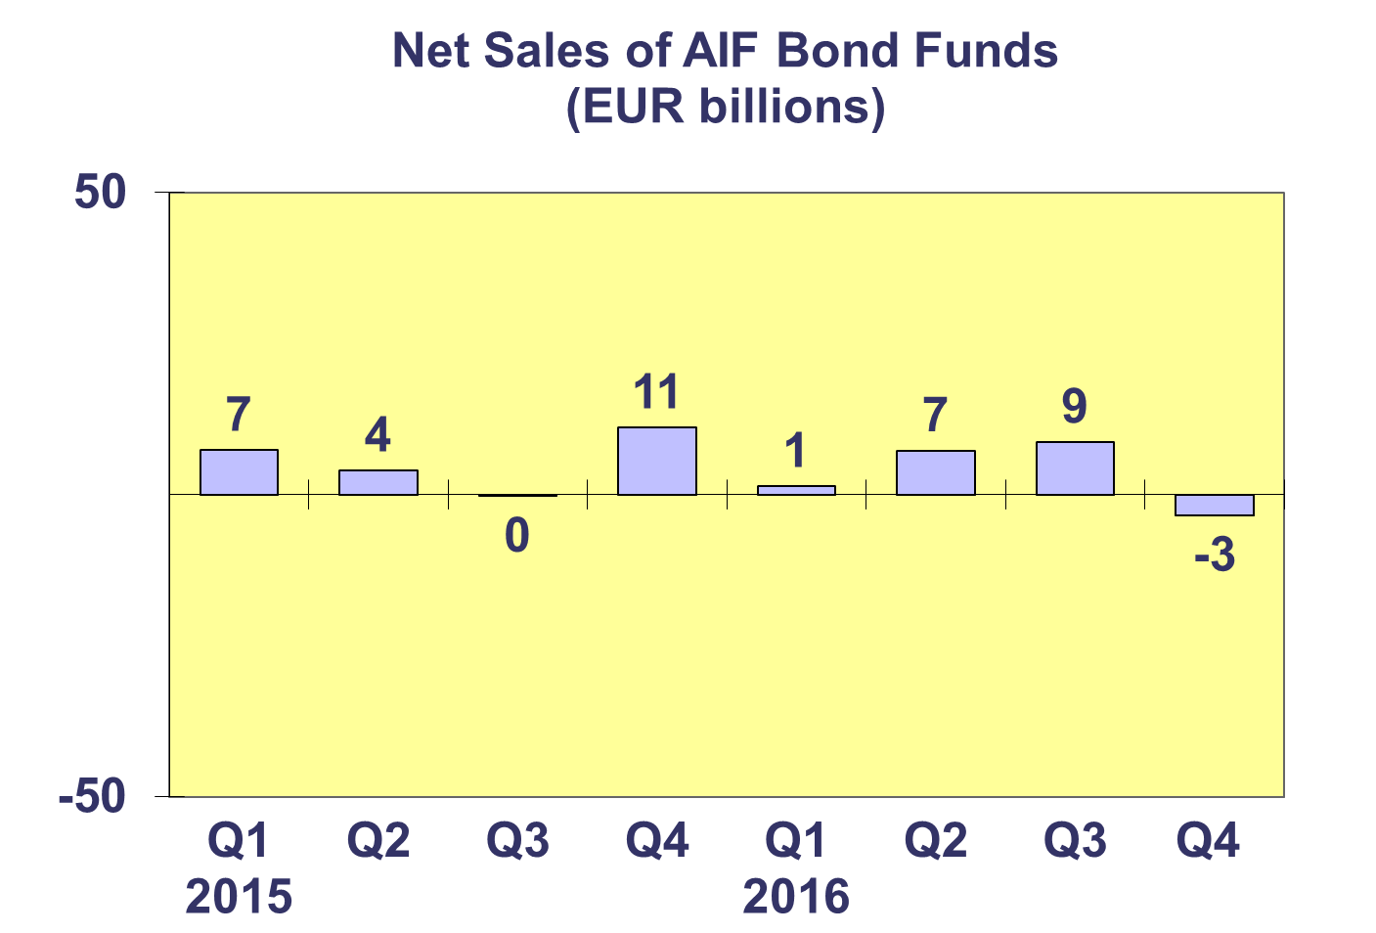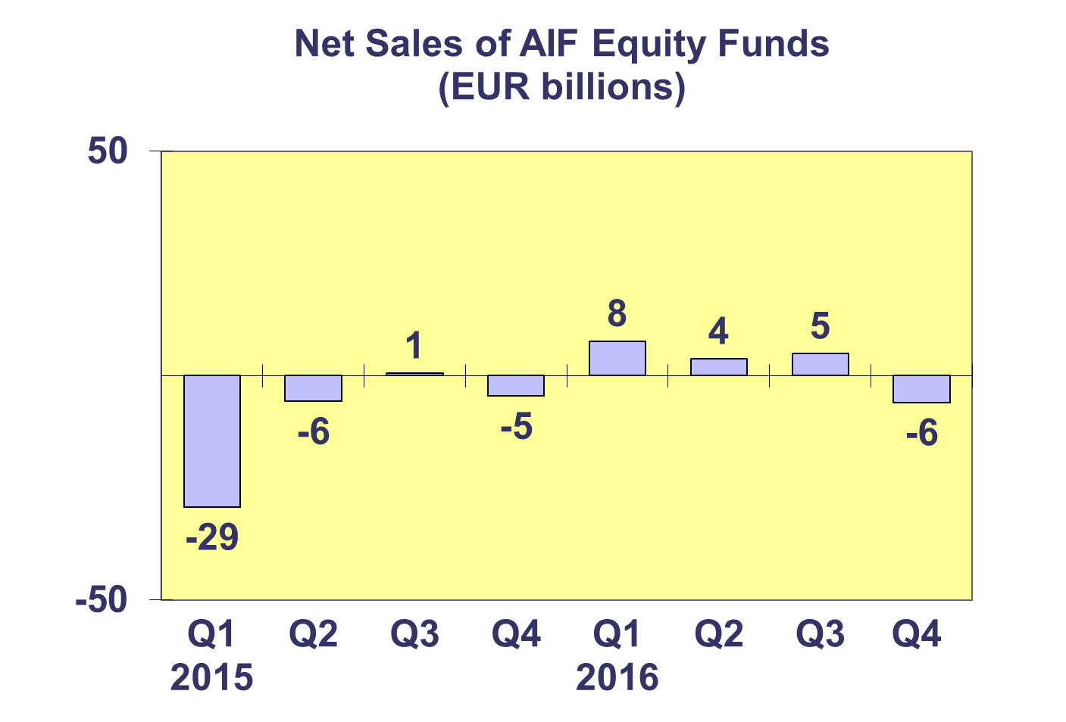**Trends in the AIF Market**

***Net Sales by Country of Domiciliation and Investment Type***

**Net sales of AIF totaled EUR 39 billion in Q4 2016, down from EUR 43 billion in Q3 2016.** All categories of AIF, except equity and bond funds, registered positive net inflows during Q4 2016.

Fourteen countries experienced net inflows into AIF in Q4 2016. The top five largest domiciles registered net sales of AIF funds above EUR 1 billion, with the strongest net flows in Germany (EUR 30.2 billion), followed by Ireland (EUR 8.9 billion), Luxembourg (EUR 6.0 billion), France (EUR 3.9 billion) and the UK (EUR 2.5 billion). Elsewhere in Europe, net sales greater than EUR 1 billion were recorded in Spain (EUR 3.2 billion) with the largest outflows recorded in the Netherlands (EUR 10.7 billion).

Six countries ended the year with cumulative net sales greater than EUR 10 billion: Germany (EUR 98 billion), Luxembourg (EUR 26 billion), Ireland (EUR 23 billion), the Netherlands (EUR 14 billion), France (EUR 14 billion) and Spain (EUR 10 billion).

 **Trends in the AIF Market**

***Net Assets by Investment Type***

**Net assets of AIF increased by 1.7 percent during the fourth quarter to end the year at EUR 5,483 billion.**

In Q4 2016, all but one category of AIF recorded net asset growth in Q4 2016. Guaranteed funds recorded the largest growth (4.6%), followed by real estate (4.5%), equity (4.0%), money market (3.3%) and multi-asset funds (1.4%). Net assets of bond funds decreased 2.6 percent in Q4 2016. Net assets of other AIF, which include AIF funds for which no breakdown according to the underlying fund categories is available, grew 2.7 percent.

There were 27,788 AIF funds at end Q4 2016, compared to 27,727 at end Q4 2015.



**Trends in the AIF Market**

***Net Sales and Assets of Institutional AIF***

**Net assets of institutional AIF, which are AIF reserved for institutional investors, increased 1.1% during the fourth quarter to end the year at EUR 2,636 billion.**

Net assets of institutional equity funds increased 3.1 percent to finish the quarter at EUR 211 billion. Institutional multi-asset fund net assets increased by 1.0% to reach EUR 982 billion. Net assets of institutional bond funds decreased 2.3% to EUR 569 billion, and real estate fund net assets increased 3.1% to EUR 160 billion. Other institutional funds experienced net asset growth of 4.9% to reach EUR 271 billion at end Q4 2016.

Institutional AIF recorded net sales of EUR 45 billion in Q4 2016, higher than previous three quarters in 2015. Total net sales of institutional AIF funds reached EUR 138 billion in 2016.



**Trends in the AIF Market**

***Net Assets by Country of Domiciliation***

**Net assets of AIF increased 1.7 percent during the fourth quarter to EUR 5,483 billion at end 2016.**

The five largest domiciles all recorded net asset growth in Q4 2016, with the largest growth in the UK (4.1%), followed by France (3.5%), Luxembourg (2.5%), Ireland (2.1%) and Germany (0.4%). Elsewhere in Europe, it is worth nothing net assets grew strongly in the Czech Republic (12.6%), Bulgaria (7.5%) and Belgium (5.1%). The largest decreases in net assets were seen in Turkey (9.5%), Poland (7.5%) and Sweden (5.3%).



**Trends in the European Investment Fund Industry**

***Net Sales by Investment Type***

**The combined net sales of the investment fund market in Europe recorded net inflows of EUR 121 billion during Q4 2016, compared to EUR 172 billion in Q3. Total European investment funds garnered net sales of EUR 459 billion in 2016, compared to EUR 738 billion in 2015.**

Net sales of equity funds registered EUR 7 billion, slightly up from EUR 6 billion in Q3 2016. Net sales of bond funds decreased from EUR 71 billion in Q3 2016 to EUR 13 billion. Net sales of multi-asset funds increased from EUR 25 billion to EUR 32 billion in Q4 2016. Net sales of money market funds decreased from EUR 43 billion in Q3 2016 to EUR 38 billion in Q4 2016. Net sales of other funds (including real estate, guaranteed/protected funds and other funds which do not fit any of the categories below or for which information is not available) totalled EUR 31 billion during the quarter, up from EUR 27 billion last quarter.

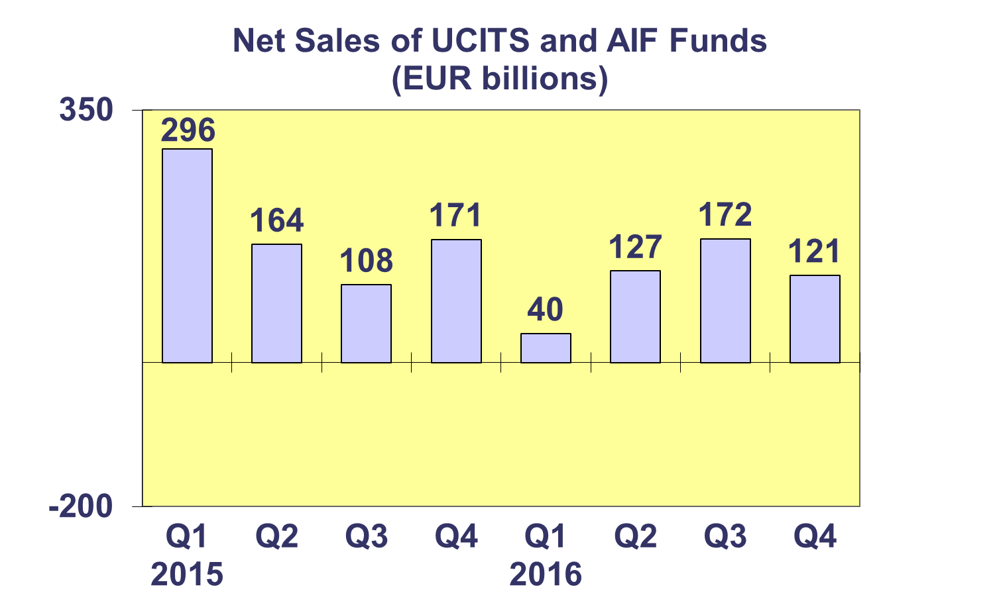

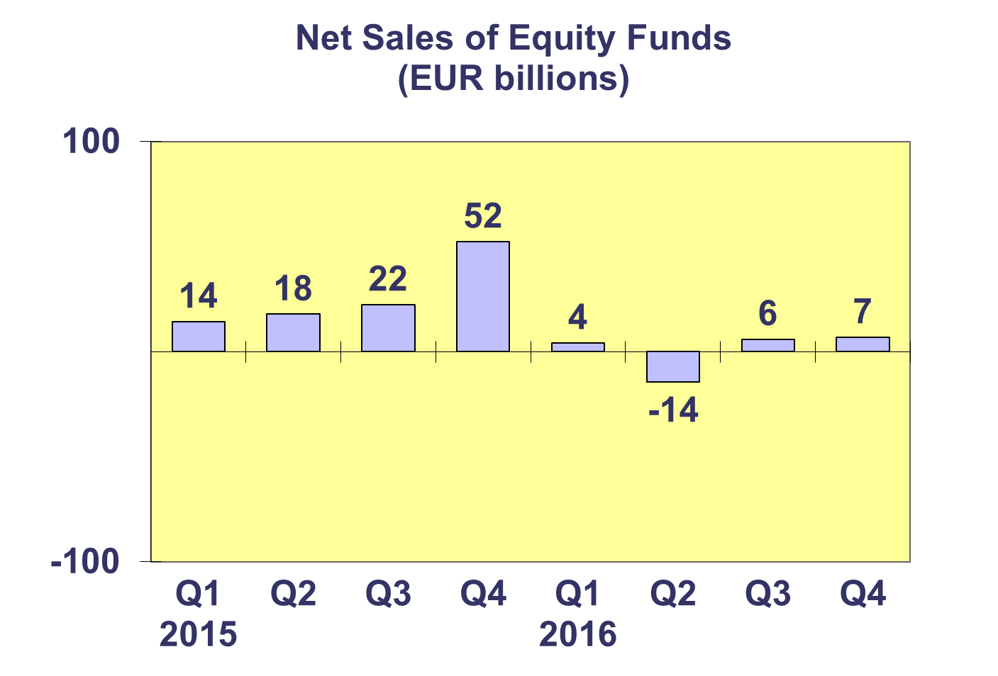

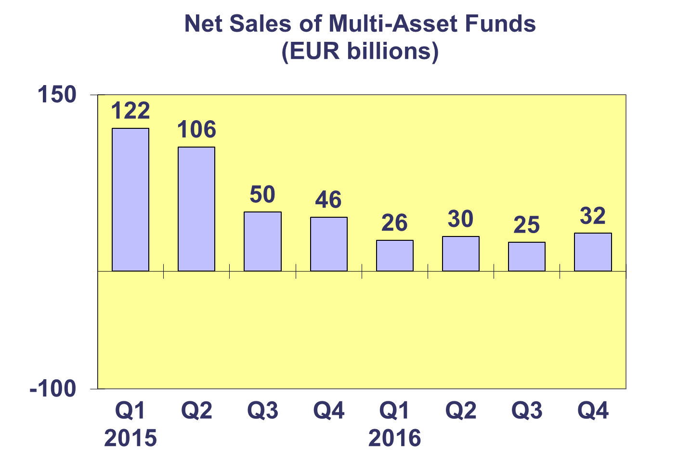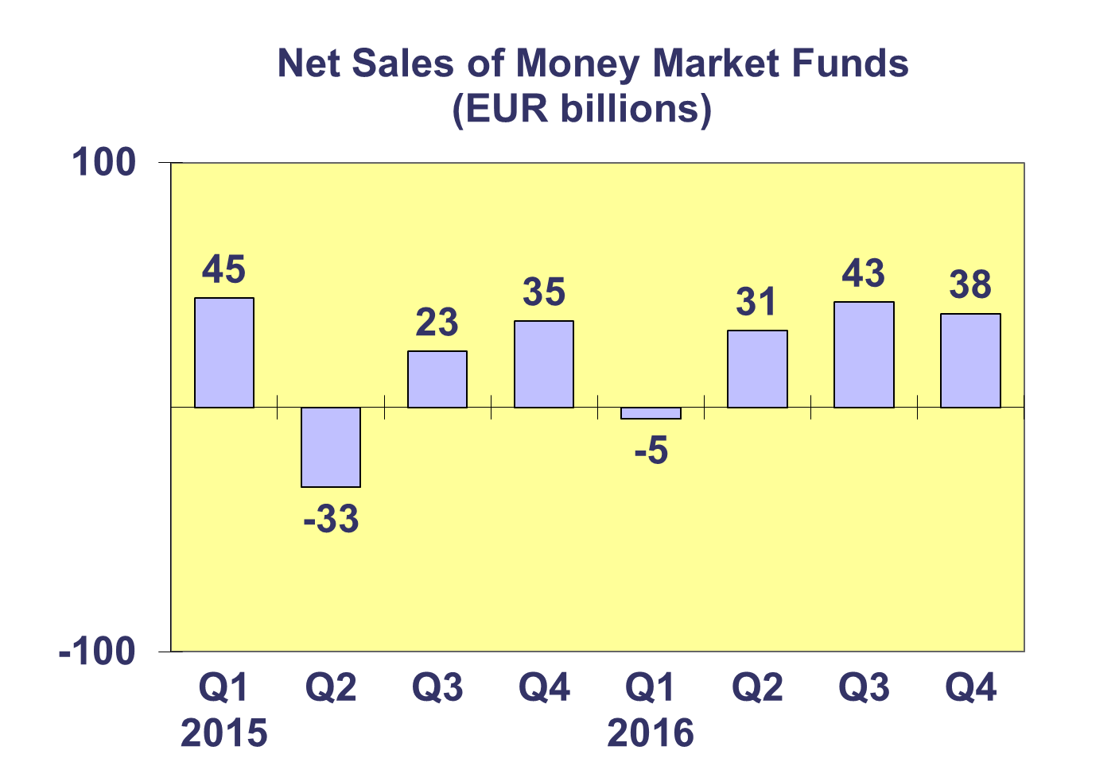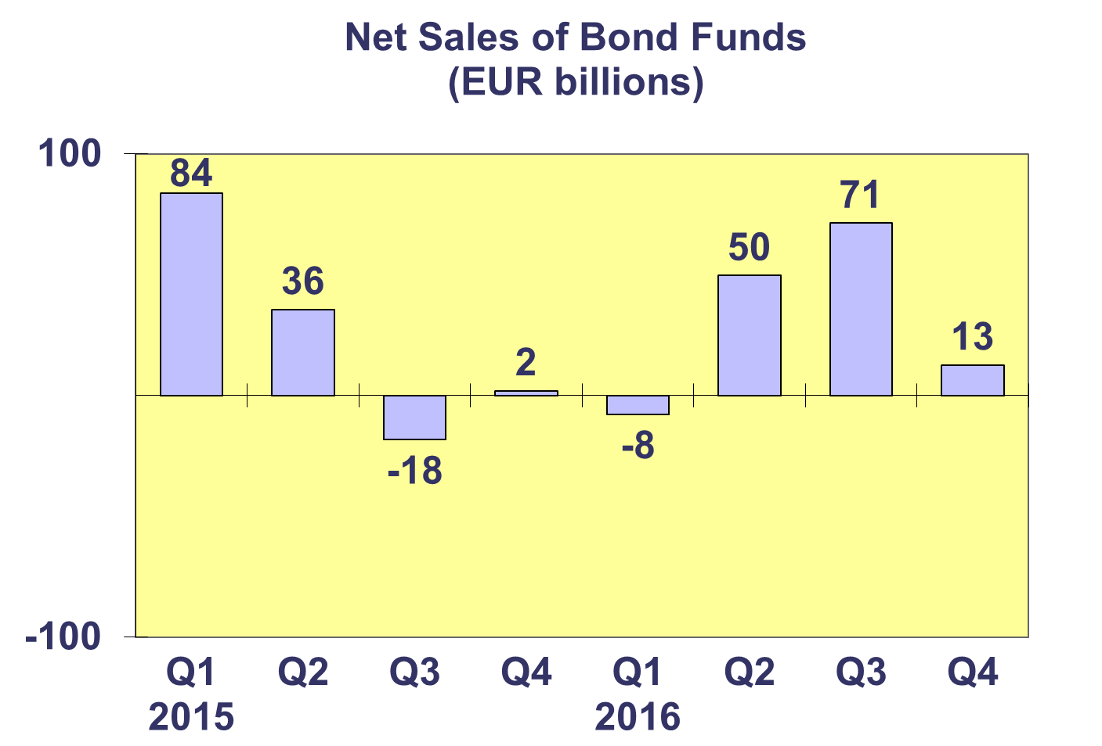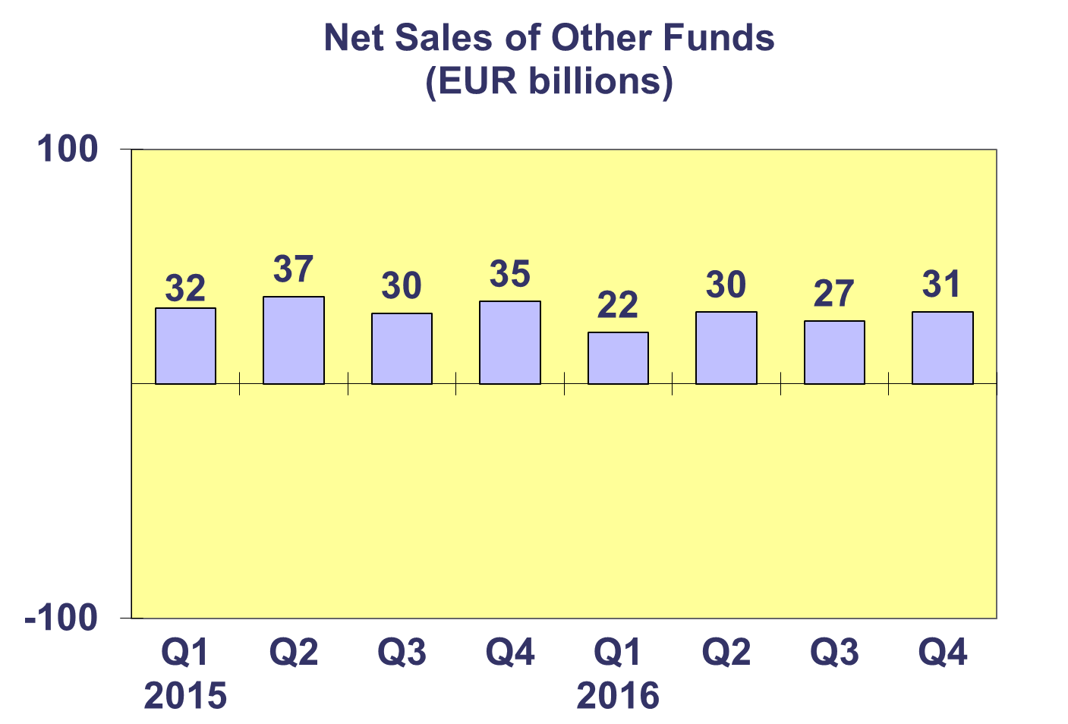**Trends in the European Investment Fund Industry**

***Net Assets by Country of Domiciliation***

**Net assets of the European investment fund industry increased by 2.6% during the fourth quarter to end the year at EUR 14,132 billion.**

With EUR 8,658 billion invested in UCITS, this segment accounted for 61 percent of total European investment fund assets at end Q4 2016, with the remaining 39 percent (equivalent to EUR 5,483 billion) coming from AIF.

The domicile with the largest annual net asset growth in 2016 was Bulgaria whose net assets grew by 30 percent, followed by Croatia (23%), the Czech Republic (18%), Norway (15%), Ireland (10%), Finland (9%), the Netherlands (9%), Germany (9%), Switzerland (7%) and Denmark (7%).

**Trends in the European Investment Fund Industry**

***Number of Funds by Country of Domiciliation***

**The total number of European investment funds increased 0.2% during Q4 2016 to end the year at 58,462 funds.**

At the end of the fourth quarter of 2016, UCITS accounted for 30,674 funds or 52.5% of the European investment fund market, while AIF accounted for 27,788 funds, or 47.5% of the market.



s

1. The net sales data presented on this page does not include net sales of UCITS ETF domiciled in Luxembourg.